CHITA WORKCAMPS AND VOLUNTEERS SERVICES ZAMBIA
CAMP CHITA OUTDOORS

MEET OUR TEAM

“Let the Journey begin”

Camp Themes
“Transforming Communities Together”,
“Camp with Easy”,
“Let’s Adventure”
SECRETARIAT
The Secretariat is the executive arm of CHITA WOVOSE ZM. This is headed by the director who is the executive officer of the social enterprise and the organization. Apart from the day to day administration and management of affairs of the organization, the director is also the secretary of the Board of Trustees. The director does not work alone, he is surrounded by young men and women who are professional and experts in their fields and together make the movement produce impactful and resolutive outcome to the ecosystem and the communities we live in.
PROFESSIONAL CAPABILITIES
CHITA WOVOSE ZM has a pool of diversely qualified and experienced professionals working across the various department or units who are actively involved in advancing the company’s objectives and vison to all programs and project implementation.
In addition, CHITA WOVOSE ZM has a pool of eminent set of volunteers who are experienced and qualified specialists in various fields (including environmental management, Health, agriculture, etc) who work along side their full-time staff and colleagues to supplement on skills, expertise and experience in the environmental and development sector.

OUR TEAM
At Camp CHITA Outdoors, our team is the foundation of our strength and success. We are a diverse group of leaders, educators, and outdoor professionals driven by a shared vision — to inspire people through nature, adventure, and purposeful learning.
With extensive experience in outdoor education, adventure tourism, youth development, and sustainable operations, our team combines expertise with innovation to deliver exceptional outdoor programs and experiences. We take pride in our ability to design and manage initiatives that are safe, engaging, and environmentally responsible, ensuring every participant and partner benefits from our commitment to excellence.
Our culture is built on collaboration, creativity, and continuous growth. We embrace innovation, integrating new ideas, sustainable practices, and emerging technologies to enhance the impact of every experience we offer.
As we look to the future, Camp CHITA Outdoors is poised for expansion — strengthening our partnerships, diversifying our programs, and broadening our reach across communities. With a passionate and capable team leading the way, we are well-positioned to drive meaningful growth, foster positive change, and set new standards in outdoor education and recreation.

EVERYTHING IS POSSIBLE WITH TEAM WORK
The Green Team
(Together Everyone Achieves More)

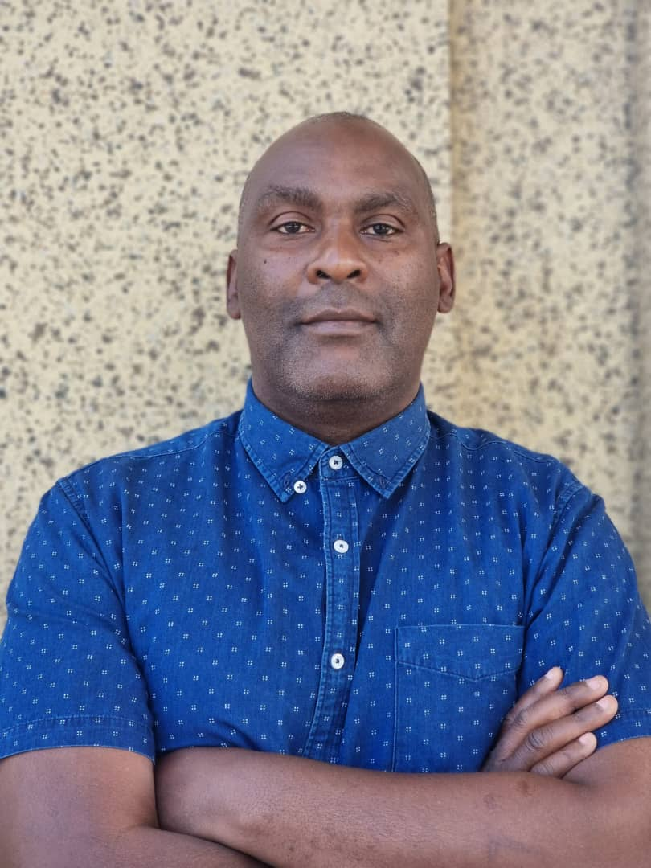

WHAT I CHALLENGE MYSELF TO: Each moment, every people I meet, any place I go to, I always challenge my mind and body to learn something NEW every day.
I believe that I open myself up to more POSSIBILITIES, more CREATIVITY and more INSPIRATION. And all the time, to try to do something outside my comfort zone and stretch a bit longer beyond my limits. To remain Humble in everything I do or have.

BIGGEST ADVENTURE: Attended Summer camp experience in Cleveland – OHIO under the YMCA Wilson Outdoor Centre in USA in 2002. Leant a lot about I (self-challenging and pushing myself to certain limits) and the passion for nature and to serve was ignited. At an amazement park in New York, I was raised to a height of 300 metres then dropped at zero acceleration on a DEAD DROP excavator – awesome experience ever.

FAVOURITE QUOTE: ‘’ You learn something valuable from all of the significant events and people but you never tough your true potential until you challenge yourself to go beyond imposed limitations”. ROY T. Bennett.

- NAME: FRANK CHITALIMA

POSITION: CHIEF VISIONARY OFFICER

ABOUT: Frank Chitalima is a nature enthusiast, an environmental and ecology scholar for the 15-past number of years. He draws his passion to care for environment and helping people to achieve their greatest dream and ambition through his personal development programs and the motivation from innovation that support eco-system and dynamics of life.

GREATEST DESIRE: To share my uniqueness with the world and make a difference in someone’s life, community or environment at large.

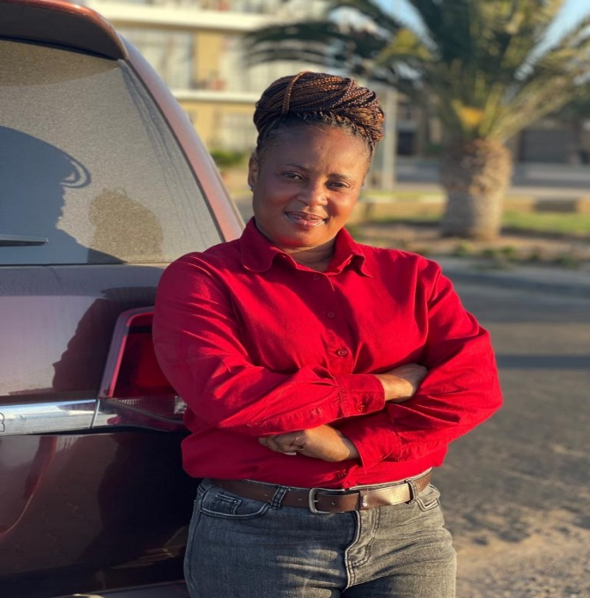
GWENY MULENGA

POSITION: PROGRAMME MANAGER

ABOUT: Gweny Mulenga, with a teaching background, has over the years been involved in office management and organization development in various institutions and boosts of experience in administrative and human resources management.

GREATEST DESIRE: To serve and save. His greatest passion has been community work and engagements of local people to bring about change. “I love to save in everything I do because I always think about tomorrow.” She hates wastage and believes in having enough is good than too much of anything.

WHAT I CHALLENGE MYSELF TO:

BIGGEST ADVENTURE: Camping expedition at the Namib Desert and the scenery and wonder sight of the Atlantic Ocean at the beach in Elvis bay – Namibia.

FAVOURITE QUOTE: “When your phone doesn’t ring in your days of struggles, make sure you don’t answer it when you are winning and thing are working out.” – Mr. F. Chita

[Photo]

NAME: CHIKO MPAMBA

POSITION: CAMP SITE MANAGER

ABOUT ME:

Keeper of the camp kingdom and master of all things organized. From tents to trails, this role makes sure the camp runs smoother than a marshmallow melting over a campfire.

GREATEST DESIRE:

To create a camp environment so welcoming that even the squirrels feel at home…but preferably not inside the cabins.

WHAT I CHALLENGE MYSELF TO:
To ensure every camper’s day starts with excitement, ends with stories, and never includes a missing sleeping bag (again).

BIGGEST ADVENTURE:
Once restored a campsite after a surprise storm—armed with nothing but determination, duct tape, and a very optimistic attitude.

FAVOURITE QUOTE:
"A good camp day is 10% planning, 90% pretending the plan is working."

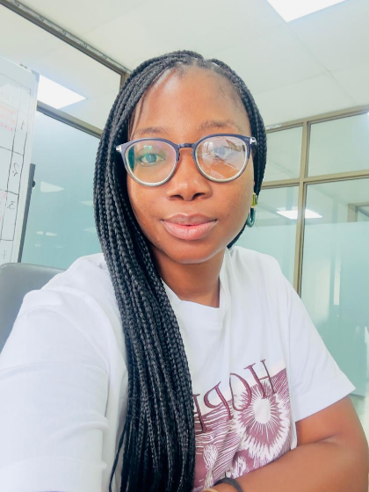

With a solid background in customer care, event management, project and team coordination, accounting, and procurement, Sarah brings a well-rounded and adaptable approach to every project she undertakes.

GREATEST DESIRE: To create seamless, memorable experiences that exceed client expectations.

WHAT I CHALLENGE MYSELF TO: I am always looking for new ways to mitigate risk, increase company efficiency and create new partnership opportunities.

BIGGEST ADVENTURE: Visited Madam Tussauds London and experienced an escape room.

FAVOURITE QUOTE: “Do the best you can until you know better. Then when you know better, do better.” — Maya Angelou

SARAH TAMIWE ZIMBA

POSITION: Events and Volunteers Coordinator

ABOUT: Sarah is a highly organized, resourceful, and professional individual with a strong passion for planning, organizing, and managing events. She possesses excellent communication skills, enabling her to interact effectively with people from diverse cultures, clients, and external stakeholders.

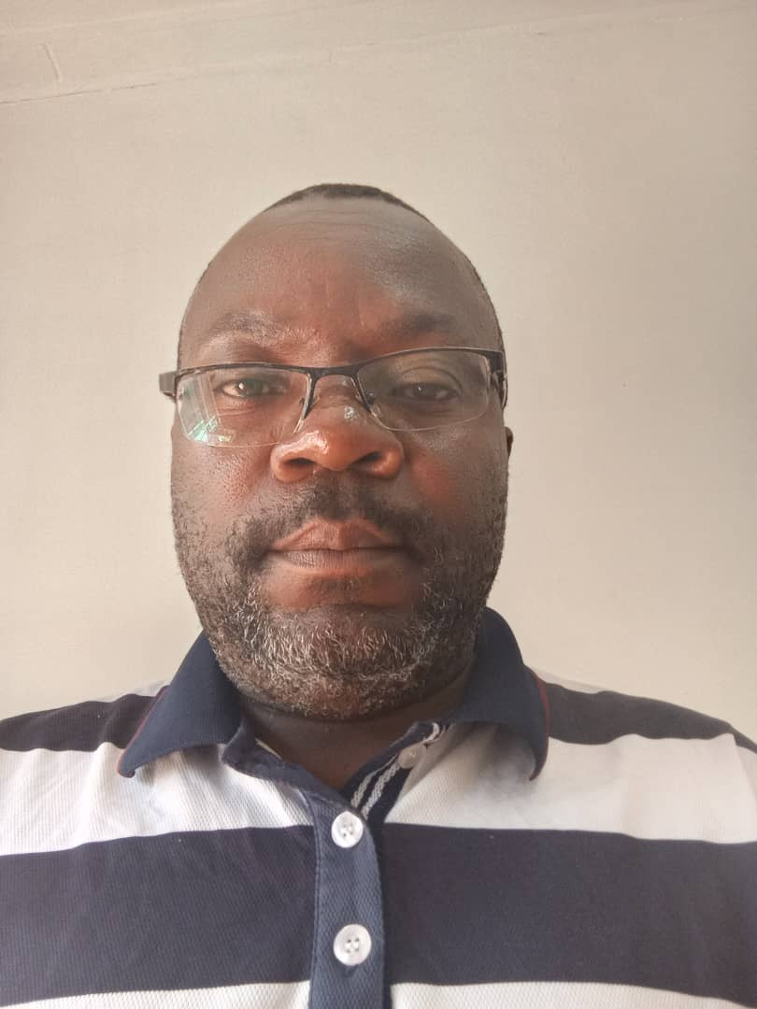

GREATEST DESIRE: Davies’ greatest desire is to empower communities with inclusive, sustainable solutions that improve health, promote equity, and build resilience against climate change and environmental challenges.

WHAT I CHALLENGE MYSELF TO: At the individual level, challenges include limited awareness of environmental issues, unsustainable practices, resistance to behavior change, and low engagement in climate action hindering efforts toward sustainability, community resilience, and environmental protection.

BIGGEST ADVENTURE: When I visited Livingstone at the big five and the crocodile farm where I had a close interaction with the Prey.

FAVOURITE QUOTE:
We won’t protect what we don’t value, and we can’t value what we don’t understand."
By: - David Attenborough.

I like this quote because it captures the essence of environmental management and climate action emphasizing the need for awareness, education, and a deep connection with nature to inspire sustainable change.

DAVIES SHULA
POSITION: Monitoring & Evaluation / Training Coordinator

About me : With over 13 years of progressive experience in program management at district, provincial, and national levels, Davies is passionate about environmental sustainability, climate change, and community development. He specializes in Monitoring and Evaluation, designing and implementing inclusive projects focused on health promotion, HIV prevention, OVC support, gender-based violence, and economic empowerment. His work emphasizes behavior change, community mobilization, and increased access to quality health services for youth, adolescent girls, and at-risk populations.

About Me

Business Administrator & Information Technician
I am a dynamic and detail-oriented Business Administrator and Information Technician with a strong passion for optimizing organizational performance through technology-driven solutions and strategic management. With a background that bridges both business operations and IT systems, I bring a unique blend of administrative insight and technical proficiency to every professional setting.
I pride myself on strong analytical skills, leadership ability, and a commitment to continuous learning — traits that allow me to adapt quickly in today’s fast-evolving digital and business landscapes.
My goal is to leverage both my administrative acumen and technical expertise to contribute to organizational success, drive innovation, and support sustainable business growth.
GREATEST DESIRE:
My greatest desire is to continuously grow — both personally and professionally — by learning, adapting, and using my knowledge to inspire others and make a positive difference in every environment I work in.
WHAT I CHALLENGE MYSELF TO:
I challenge myself to go beyond comfort zones, to continuously improve my skills in business administration and information technology, and to find innovative solutions that make organizations more efficient, connected, and future-ready..
BIGGEST ADVENTURE:
My biggest adventure has been building my career at the intersection of business administration and information technology learning how to blend strategic thinking with digital innovation to create lasting impact and continuous growth.

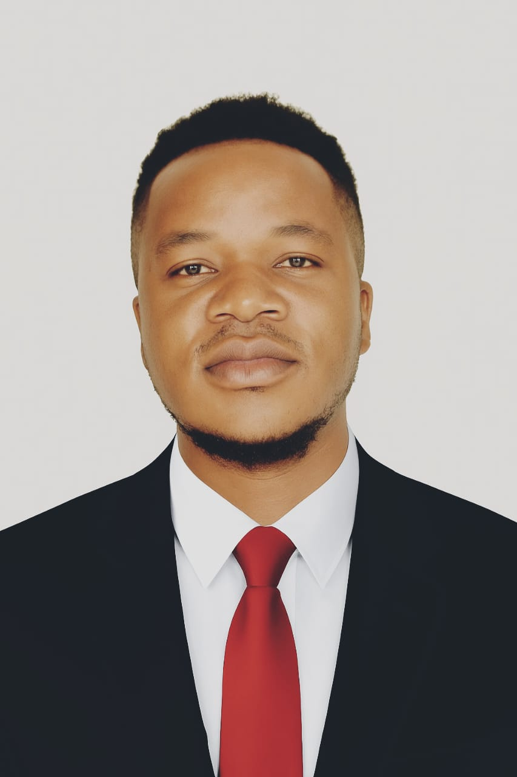

SOPHTY BROWNY
POSITION: Communications / Media Coordinator (Liaison)

FAVOURITE QUOTE:

The future belongs to those who believe in the beauty of their dreams
This quote reminds us that belief is the foundation of achievement. It means that the people who shape the future — innovators, leaders, and dreamers — are those who dare to see possibilities beyond current limitations and have the courage to pursue them.
@Teamchita

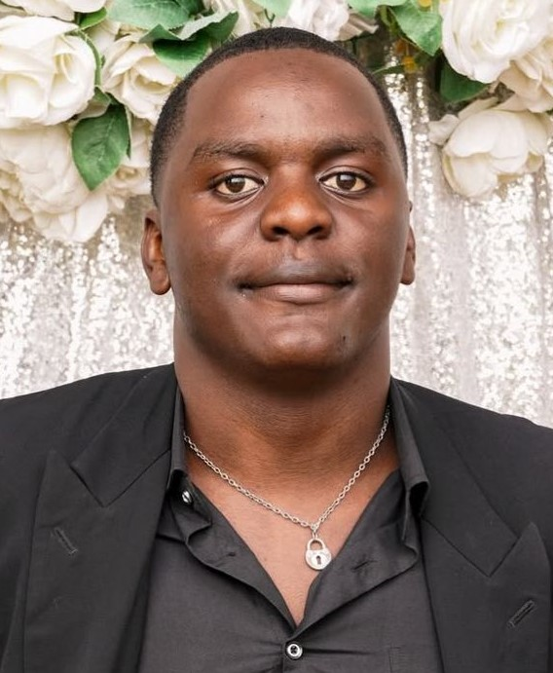

NAME: Anderson Zulu

POSITION: SENIOR OUTDOOR OFFICER

ABOUT:
Chief Adventure Architect and fearless leader of hikes, survival missions, and all things exhilarating. Ensures campers explore safely while discovering their inner trailblazer.

GREATEST DESIRE:

To build strong, confident explorers who laugh, learn, and sometimes forget they’re exercising.

WHAT I CHALLENGE MYSELF TO:

To help every camper find bravery—even if it starts with conquering the terrifying challenge of… tying their shoelaces in double knots.

BIGGEST ADVENTURE:

Completed a multi-day mountain trek with a group of campers who packed everything except raincoats. (Lesson learned: always double-check the packing list.)

FAVOURITE QUOTE:
"Adventure begins where comfort zones end… and where snacks never run out."
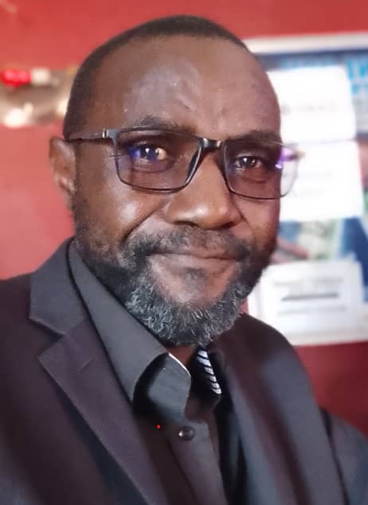

NAME: Michael Mshoka

POSITION: COMMUNITY ENGAGEMENT OFFICER
ABOUT Me: Hey everyone! I’m Michael — a big believer in the power of people coming together to create change. I love connecting with communities, sharing ideas, and helping others discover what makes them shine. You’ll usually find me chatting with new friends, organizing activities, or finding ways to make every voice count.
GREATEST DESIRE: To see young people grow with confidence, purpose, and passion for making their world a better place.
WHAT I CHALLENGE MYSELF TO: I push myself to always try something new — whether it’s learning a new skill, starting a new project, or stepping into the unknown with a positive attitude.

BIGGEST ADVENTURE: Taking part in a community development project deep in the countryside — meeting amazing people, learning their stories, and working side by side to build something meaningful.

FAVOURITE QUOTE: “Alone we can do so little; together we can do so much.” – Helen Keller
“Beauty is nothing if your tongue is ugly” – by unknown.

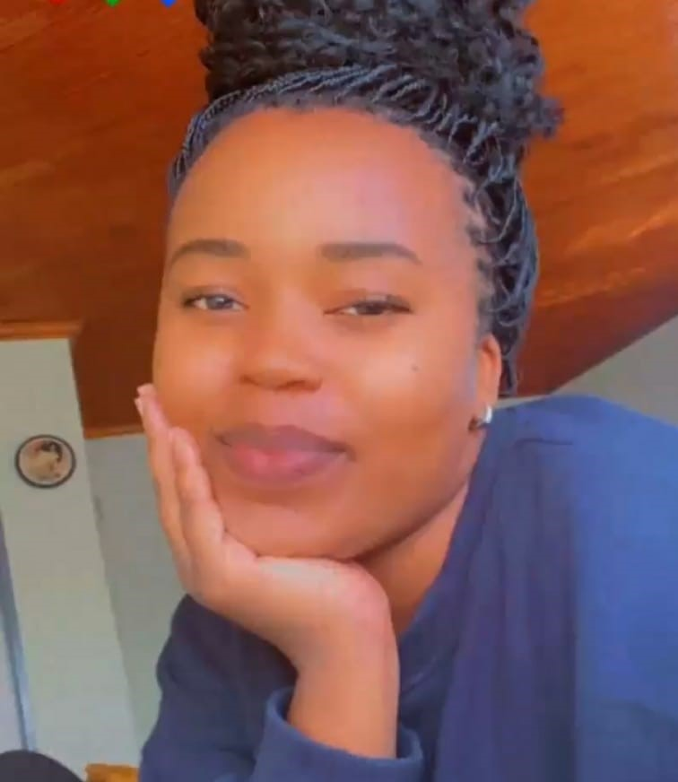

NAME: Eleanor Mwamba Sakala

POSITION: ENVIRONMENTAL EDUCATION OFFICER

ABOUT:
Nature’s biggest fan and the camp’s walking encyclopedia of weird animal facts. Leads adventures that turn forest walks into epic discoveries and teaches everyone how to leave the planet better than they found it.

GREATEST DESIRE:
To help campers fall wildly in love with nature—but not too wildly, because hugging porcupines is not recommended.

WHAT I CHALLENGE MYSELF TO:
To inspire at least one camper a day to say, “Whoa, I never knew THAT!”

BIGGEST ADVENTURE:
Tracked mysterious footprints for hours in the woods… only to discover they belonged to a very confused goat.

FAVOURITE QUOTE:
"Take only memories, leave only footprints… and maybe a snack for the goats."

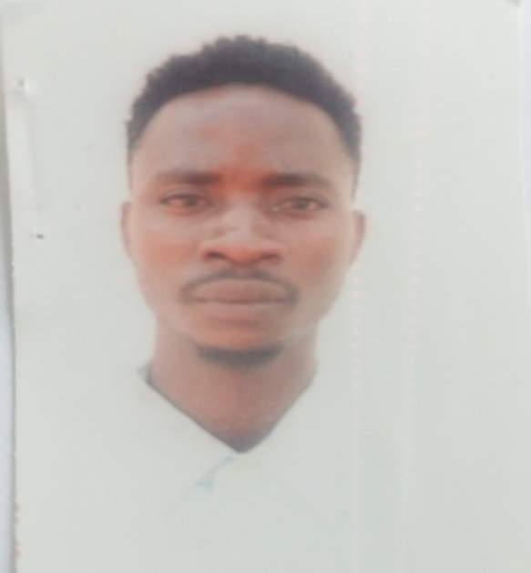

NAME: Phillip Sakala

POSITION: CAMP SITE CARE TAKER – The groundman

ABOUT: Hi, Phillip here. I am the one who makes sure Camp CHITA always looks its best and feels like home. I take pride in keeping our spaces clean, safe, and full of good vibes. When I’m not fixing something or tending to the grounds, you’ll probably find me sharing a laugh with campers or helping out wherever I’m needed. I am very hard working and have a passion to care for nature and vulnerable groups in society. I can mix freely with all kind of people and I am a self-motivated person whose desire is see others do better and advance in life.

GREATEST DESIRE: He is outgoing and flexible. He enjoys working with groups and likes attempting new things that takes him to new heights.

WHAT I CHALLENGE MYSELF TO: I get inspired being part of solution and playing a role to make life better and worthwhile for other people and society as a whole.
BIGGEST ADVENTURE: I once worked through a huge storm to make sure the camp was ready for a camp event — it was tough, but seeing everyone enjoy the day made it worth it!
Also, to see every camper, leave with a smile and great memories of their time here.
FAVOURITE QUOTE: “Do what you love, love what you do.”

